

Community, Health and Environment Research Centre

Understanding Industrial Development in Alberta’s Rural Communities

Interim Report #1

July 31st, 2003

Theresa Garvin and Jeff Masuda
Department of Earth and Atmospheric Sciences
University of Alberta



Introduction
Our project, now titled Understanding Industrial Development in Alberta’s Rural Communities is at the midpoint of data collection and is now early into analysis. At the time of the CARCI award (May, 2003), the project was early into Phase 2, having completed part of the document analysis and approximately 10 interviews. A project assistant, Leah Gold, began in May to provide administrative support in communicating with project stakeholders, record-keeping, literature searches, and document retrieval. We completed the remaining interviews between May and June. Currently, we are planning subsequent phases of the project with the Community Advisory Committee and anticipate completion of data collection by September 15th.

Early collaboration with the Community Advisory Committee led to slight adjustments of the project goals objectives to satisfy some suggestions members had over the focus of the project and utility of the expected results. As such, the project’s main goal is to promote positive relationships between citizens and government in communities facing industrial development. We are meeting this goal with four objectives:

- To reconstruct the events associated with planning in a community undergoing industrial development. This will include a longitudinal review of local and provincial policies, reports, legal proceedings, media coverage, and decision-making;
- To identify similarities and differences in viewpoints about industrial development between individuals and groups in a cross-section of the community. Key players in the case study will include landowners and residents, local government, business, and industrial organizations;
- To build community capacity and trusting relationships among individuals and groups in the study community; and
- To construct an improved framework for community consultation that may be used in communities facing future industrial development, with the intention of strengthening linkages in such communities.

This report contains the preliminary results based on 28 interviews, 11 of which have received initial coding.

Overview of Project Activities

Document Analysis
The document analysis comprises media, provincial and municipal legal and regulatory sources, and Heartland promotional documents. Table 1 identifies the documents obtained to-date. We selected four newspapers based on their distribution to residents of the Heartland area. Articles are currently being catalogued according to date, newspaper name, page number, length, headline, and type of article. Articles are being subjected to content analysis techniques where they are being coded and categorized by theme. These themes are then compared to the timing of the newspaper coverage over the course of the Heartland public consultation process between 1998 and the present.
Table 1a. Media Documents
Type | Source | N | Inclusion criteria
Media | Sturgeon Creek Post (1998 – 2001) ¹ | 60 | All articles relating to industry
 | Fort Saskatchewan Record (1997-1999)¹ | 457 | All articles relating to industry
 | Fort Saskatchewan This Week¹ | 17 | All articles relating to “Heartland” sent by editor
 | Strathcona County This Week¹ | 0 | All articles relating to industry
¹Indicates document retrieval still in progress

Table 1b. Laws and Regulations
Level of Government | Document
Provincial | Alberta Municipal Government Act
 | Alberta Energy and Utilities Board Act
 | Alberta Personal Property Bill of Rights
 | Alberta Environmental Protection and Enhancement Act
Municipal | Fort Saskatchewan Bylaw C-19-00 – AIH Area Structure Plan (2001)
 | Strathcona County Bylaw 65-2001 – AIH Area Structure Plan (2001)
 | Sturgeon County Bylaw 19/00 – AIH Area Structure Plan (2001)
 | Lamont County Area Structure Plan (2001)

Table 1c. Heartland Documents
Complementary Area Structure Plans Background Report (January 2002)
Land Use Planning in Alberta’s Industrial Heartland (Public information sheet, April 2000)
Land Use Planning in Alberta’s Industrial Heartland (Public information sheet, January 2000)
Land Use Planning in Alberta’s Industrial Heartland (Public information sheet, 1999)

Interviewing

Phase 2 interviews included a total of 28 participants selected by both snowball and random methods. The sample comprises five groups, including 17 landowners (N= 9 random, 9 snowball), of which 14 are farmers or absentee farmers, 3 own country residential properties; 8 are local politicians or administrators, and 3 represent industry and the media.

To achieve randomness of the landowner sub-groups, we overlaid the Heartland boundary onto the four municipality land ownership maps, selecting a total of 259 eligible residences. We searched for telephone numbers using an online directory, yielding a total of 126 unique telephone numbers (48.6%). We called these numbers at random until we successfully recruited the desired sample (N=40, 26 unreachable, 4 declined: response rate = 71.4%). Geographic distribution of the landowner group can be seen in Appendix A.

All participants in the landowner sub-group as well as half of the politician sub-group preferred to be interviewed in their homes. The remainder were conducted at the workplace of the participant. Interview lengths varied from 29 to 83 minutes, with an average of 45 minutes. Demographic information collected prior to the interview from each participant included age, length of residency, gender, education, marital status, household members, ethnicity, occupation, and family income (Table 2). We achieved a reasonably even geographic distribution (see Appendix A) among the landowner group. Participants were predominantly 40 – 70 (86%), long-time residents (>10 years = 94%), married (95%), male (81%). Most had either a high school or technical diploma (62%) and had a relatively high income (>$60,000/year = 57%). There were no visible minorities among the sample.

During the interview, participants responded to a series of prepared questions that acted as a guide to the conversation. This included background information of the participant and their experiences with/in the Heartland as a place, views on the relationship between industry and the communities within the Heartland, role during the development of the Heartland (i.e. public involvement processes), and their perspectives on the opinions of different groups during the processes.

Table 2. Participant Demographics
 |  | Total
Location | Lamont | 3
(N=27) | Sturgeon County | 9
 | Strathcona County | 8
 | Fort Saskatchewan | 7
Age | 20-40 | 1
(N=22) | 40-50 | 6
 | 50-60 | 6
 | 60-70 | 7
 | 70+ | 2
Residency | < 5 years | 0
(N=18) | 5 – 10 years | 1
 | > 10 years | 17
Education | High School or less | 7
(N=21) | Technical/Professional | 8
 | University | 6
Marital Status | Single
(N=21) | Common-law | 1
 | Legally married | 20
 | Separated/Divorced | 0
 | Widowed | 1
Gender | Male | 22
(N=27) | Female | 6
Occupation | Agriculture | 6
(N=23) | Homemaker | 2
 | Government and Elected Government Officials (past and present) | 7
 | Media | 1
 | Education | 1
 | Business/Management | 4
 | Retired | 2
Family Income | <$40000 | 4
(N=22) | $40000-50000 | 4
 | $50000-60000 | 2
 | $60000+ | 12

Challenges faced during data collection and strategies taken to overcome them;

Community Advisory Committee
At the first Community Advisory Committee meeting, it became clear that our local partners desired to have broader representation among local and other relevant stakehodlers. Since then, we have taken steps to recruit additional members, with limited success. Barb Korol, communications director for Dow Chemical; Ernie Vanboom, Alberta Potato Producer’s Association; Jennifer Klimek, an environmental lawyer and president of the Alberta Environmental Law Centre; and a Brad Trefan, from Alberta Economic Development (Alberta Tourism and Industry), have agreed to participate on the committee. Efforts to include other relevant stakeholders are ongoing.

Preserving Anonymity

We have taken several steps in order to ensure the anonymity of our participants, however, several participants who are well known in their communities have been concerned that their comments will be attributed to them. To address this concern, we have built a respondent feedback mechanism into our project design where participants receive copies of their interview transcript and can add, delete, or amend the transcript as they see fit. This procedure gives participants a sense of control at the outset of the interview, thereby helping to facilitate more honest and meaningful responses. In some cases, this process has required additional in-person meetings with participants to reassure them that their changes were being made correctly. In addition, prior to public dissemination of results, we will verify all quotations used with respondents.

Highlights of significant preliminary results of the project to-date

Document Analysis
So far, we have conducted preliminary coding for 77 newspaper articles obtained to-date. Figure 1 represents a typical example of the level of coverage given to the Heartland between 1998 and 2001. Comparing counts of articles to the timeline (see Appendix B) of events may provide insight in the influence of media on public knowledge of the Heartland. For example Figure 1 shows the relationship between coverage and significant periods during the public involvement processes undertaken by the four municipalities.

Heartland announced
1st Open Houses
2nd Open Houses
Citizen’s Coalition
Approvals
Award
Figure 1. Frequency of stories relating to Alberta's Industrial Heartland in the bi-weekly newspaper Sturgeon Creek Post (online version) between 1998 - 2002.

Interviews
Preliminary coding on 11 of the 28 interviews has given some early insights into the people involved with the Heartland, and their views on the issues associated with the industrial development and the community. Ongoing free coding has so far yielded a total of 309 codes. Of these, 256 have been categorized into 11 emerging categories (Table 3). In-depth analysis of the data is ongoing and will be documented in the final report.
Table 3. Preliminary coding report for the first round of interviews.
Category | Sub-nodes | Examples
“Participation” | 35 | - “Meetings”  - “No consideration”  - “Consultation”  - “Competing opposition”  - “Listening”  - “Tried to involve public”  - “Public ignoring Heartland”
“Place” | 28 | - “Industry and people are incompatible”  - “Lost legacy”  - “Quality of life”  - “Who suffers, who benefits”  - “Industry and community need each other”
“Risk” | 21 | - “Health concerns”  - “Limits on industry”  - “Risk communication”  - “NIMBY”  - “Uncertainty”
“Heartland Issues” | 21 | - “Land use”  - “Distances”  - “Noise”  - “Buy-out”  - “Notification”
“Attitudes and Relationships” | 18 | - “Community-Industry”  - “Politicians not knowledgable”  - “Trust”  - “Council versus Administration”
“Feelings” | 12 | - ‘Discouraging”  - “Scary”  - “Emotional”  - “Concerned”
“Forecasting” | 11 | - “Future protest”  - “Solutions offered”  - “Uncertain future”  - “Nothing happening”
“Politics” | 6 | - “Provincial involvement”  - “Intermunicipal fighting”
“Rural Restructuring” | 5 | - “Change in agricultural sector”  - “Plant employment”  - “Off-farm work”
“Structural Variables” | 3 | - “Age”  - “Home”  - “Employment”
“Frames” | 3 | - “Lay awareness of Heartland”  - “Media construction of Heartland”  - “Political views of Heartland”

Plans for conducting subsequent phases

Phase 3 employs follow-up interviews with 20 of the participants who were interviewed in the previous phase. These interviews will explore in depth prominent themes that arose from the groups, giving participants the opportunity to reflect further upon their own experiences in light of similar and different perspectives given by others. The interview guides will be formulated based on the results of the first round of interviews and suggestions from the Community Advisory Committee. We will conduct interviews in the fall, selecting participants based on geographical distribution, quality of responses in the initial interview and cross-representativeness among the five groups.

Finally, the Community Advisory Committee will convene again upon completion of these interviews and prior to the final Phase of data collection. In this phase we will conduct one to two group interviews with our participants to present our results and discuss their implications.

Stakeholder Relevance

The Community Advisory Committee participated in a teleconference on July 9th to discuss the preliminary results of the project. The findings so far confirm their experiences with stakeholder communities both within the Heartland and in other jurisdictions in Alberta. Members indicated that they are looking forward to the subsequent phases of the project.

Jeff Masuda presented the preliminary results of interviews with Heartland landowners to the Canadian Association of Geographers in May, 2003. The presentation was well received by those in attendance, whose input and expertise is invaluable to the project. In addition, Jeff Masuda received a travel award to attend the Society for Risk Analysis Conference in December, 2003 where he will present some of the final results of the project. This association will benefit the project by providing further international expertise and feedback on the emerging results.

Appendix A: Heartland map showing participant distribution.
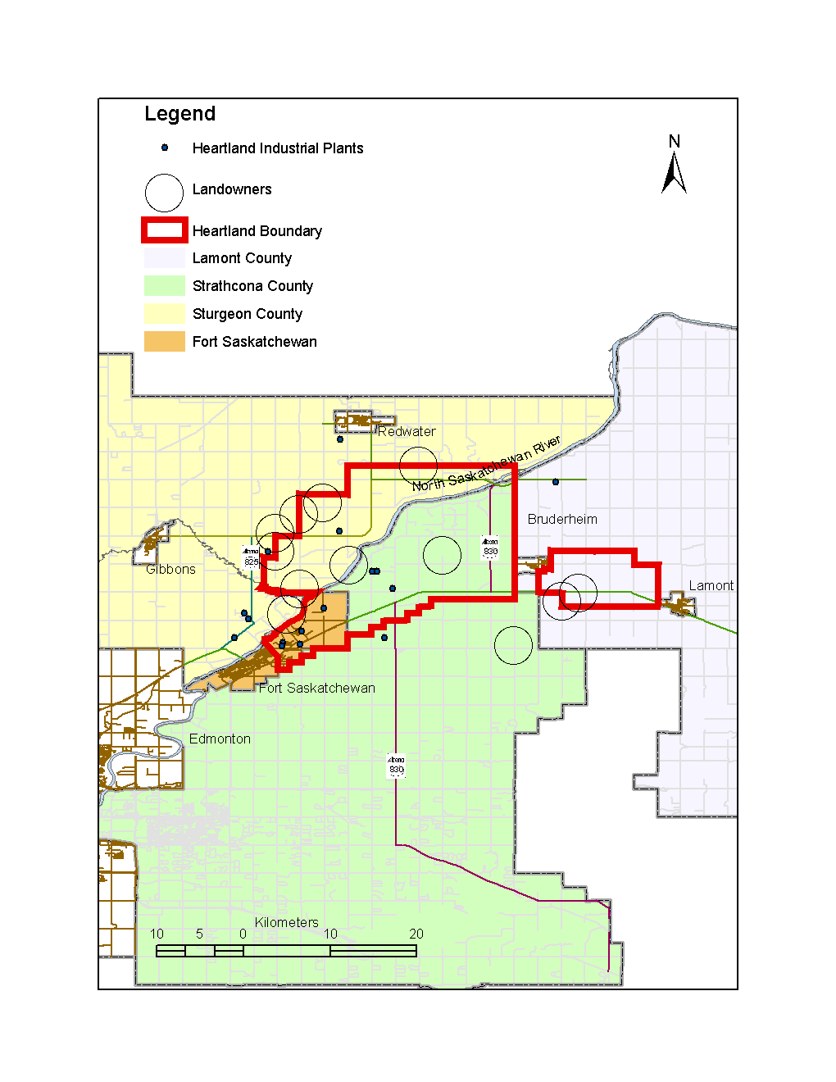
Appendix B: Heartland Timeline 1998 – 2001

Date | Event
1993 | Strathcona, Ft Sask, Sturgeon, Lamont, Ft Sask Regional Industrial Association become informal partners
27 May 1998 | Partnership formalized to become the Alberta’s Industrial Heartland Association
Sept – Oct 1999 | AIHA review of background material, study area
03 Nov 1999 | Josephburg “Open House”
04 Nov 1999 | Redwater “Open House”
09 Dec 1999 | “Workshop” for 60 key stakeholders to provide detailed information
Jan 2000 | 3 Area Structure Plans prepared and reviewed
Feb 2000 | Revised plans presented to AIHA partners
16 Feb 2000 | Revised plans presented in Gibbons “Open House”
17 Feb 2000 | Revised plans presented in Ft Sask “Open House”
10 May 2000 | Final open house in Gibbons for complementary plans
11 May 2000 | Final open house in Bruderheim
09 June 2000 | Invited industry reps meet to discuss plans
25 June 2000 | Fort Saskatchewan Public Hearing on Bylaw #C19-00 and C8-01
30 June 2000 | Steering committee meeting attended by municipality representatives to provide input on public concerns
10 Aug 2000 | Finalized CASPs submitted to steering committee
Aug 2000 – June 28 2001 | “Extensive review and public/industry/regulator consultation”
Nov 2000 | 24 landowners to be bought out by Strathcona County
Nov and Dec 2000 | Four Public hearing on the four ASP’s.  Fort Saskatchewan (Dec. 11)
Nov 2000 | “Newsletter #4” encourages participation at public hearings
18 Dec 2000 | Steering committee meets to discuss results of public hearings and alternative approaches to the planning process
04 Jan 2001 | Heartland Citizen’s Coalition formed
 | Letter sent to Sturgeon County Council
08 Jan 2001 | Steering committee meets to detail plans
10 Jan 2001 | AIHA and municipality staff meet with town of Bruderheim at their request to discuss Heartland and CASP project
Jan – June 2001 | Facilitator assisted AIHA and municipalities for “extended and intensive public consultation: with regard to each ASP
March 2001 | Open house
23 April 2001 | 2nd and 3rd readings of Fort Saskatchewan Bylaw #C19-00
April 2001 | Additional public hearings
25 June 2001 | Ft Sask public hearing
10 April 2001 | Final approval by Lamont and Sturgeon
26 June 2001 | Final approval by Strathcona
13 Aug 2001 | Final approval by Ft Sask

