Understanding Industrial Development in Alberta’s Rural Communities

Final Research Report

January 31st, 2004

Theresa Garvin and Jeff Masuda
Department of Earth and Atmospheric Sciences
University of Alberta



Table of Contents
1. Executive Summary 2
2. Introduction 4
Background 4
3. Research Results 6
Newspaper Analysis 6
Individual Interviews 12
a. Public Consultation 13
b. Space versus Place in a Changing Landscape 14
c. Risks versus Benefits 16
d. Trust, Attitudes and Relationships 18
e. Forecasting and Future Expectations 20
f. Power and Politics 21
Group Interview 22
4. Conclusion 24
References 25
Appendix A: Community Advisory Committee 26
Appendix B: Methods 27
Appendix C: Heartland Timeline 1998 – 2001 30

Executive Summary
This is a case study of the Alberta’s Industrial Heartland (hereinafter referred to as the AIH). The project was carried out between May and December 2003. This report presents findings from original research conducted through the Community, Health and Environment Research Centre at the University of Alberta. This report is comprised of results from the second interim reporting process and the final research conclusions which, together, make up this final research report.

The AIH is both a major petrochemical centre and a series of policy initiatives undertaken by local governments to facilitate increased industrial development in a rural region near Edmonton, Alberta. The project examined the public consultation process (locally referred to as “public involvement”) that took place between 1998 and 2001 with the rural communities inhabiting the AIH region. Preliminary investigation showed that there was considerable community conflict during the AIH’s developmental phase, with the consultation processes pitting segments of the community against one other, as well as against local government and industry.

The purpose of the project was to understand the reasons for community conflict. We conducted a newspaper analysis and a series of interviews (individual and group) to explore the ways that industry and the AIH were viewed (1) in the local news; and (2) among the multiple stakeholders and community members.

Results of the newspaper analysis showed that local newspaper sources played an important role in re-constructing events, opinions, and conflicts related to the AIH. Newspaper stories may have influenced the ways that the community thought about the AIH in the following manner:

- The amount of newspaper coverage increased at critical events of the Heartland;

- Coverage of risks and benefits of industry, as well as positive versus negative coverage of the AIH may have contributed to the conflicting viewpoints between community members and local officials;

The individual and group interviews provided in-depth accounts of the experiences and interactions of citizens, government, industry, and media stakeholders in the region. Participants expressed both positive and negative viewpoints about proposed policies of the AIH. Important issues that were identified include:

  - The consultations failed to meet the expectations of many community members and officials;

  - Community members and officials did not agree on whether the region set aside for the AIH should be agricultural, a place for country living, or an eco-industrial park;

  - Community members living in or near the AIH believed that they must bear the majority of the costs associated with industry, while they will share little of the benefits;

  - A considerable degree of mistrust existed among government, industry, and the community as a result of negative attitudes and experiences during the AIH consultations;

  - The conflict between the community and government was expected to continue, possibly hindering the implementation of the AIH;

  - It is uncertain who held decision-making power to drive the political and economic agenda for the AIH (i.e. government, industry, or the community).

These results will form the basis of a series of recommendations that comprise a framework for community consultation. Finally, project findings are to be disseminated to stakeholders in the Heartland with the assistance of the community advisory committee (see Appendix A). This will include informational brochures, a project website, and presentations to local organizations. These items will be included in the final project report.

Introduction

Our project, titled Understanding Industrial Development in Alberta’s Rural Communities was completed in January, 2004. Since our last report (CARCI Interim Report #1, August 2003), we have completed our newspaper analysis, two rounds of individual interviews (first round: n=30; second round n=14), and a group interview (n=7). This report summarizes project activities that took place from August 2003 to January 2004 and reports findings from the second interim reporting process as well as final research results.

Background

The AIH is located approximately 30 km northeast of Edmonton, Alberta. It is a 330km² region that includes four municipalities: Lamont County, Sturgeon County, Strathcona County; and the City of Fort Saskatchewan (Figure 1). The region is a major petrochemical hub of North America, and local governments have been interested in attracting large-scale global investment to expand its industrial profile. To accomplish this, planners developed complementary area structure plans and land use bylaws to reduce bureaucratic obstacles and create a business friendly economic environment in the region.

Occupying the local landscape are several different types of rural communities, including farmers, acreage owners, and residents of rural subdivisions. In 1998, local governments began a series of public consultations to inform local landowners and residents of regional plans to re-zone and develop a large industrial area at the intersection of the four municipalities.

Early consultations consisted of a series of open houses that were designed to provide the community with basic information about the AIH proposal. Over time, public dissatisfaction with the consultation processes and the content of proposed policies began to grow stronger, and the purported merits of the AIH came under increasing community scrutiny. Some community members reported being displeased that they had not been adequately consulted at the outset. They were concerned about risks that could result from increasing industrial activity in the region, including risk to health, safety, livelihood, and quality of life. By early 2001, a grassroots citizen’s coalition had formed to represent the community’s concerns in consultations and public hearings and to communicate with local newspapers to report public dissatisfaction. In the end, the AIH policies were passed by all four municipalities in late 2001.

Since that time, the coalition has been active in opposing any further implementation of the AIH until its members are satisfied that the community’s concerns are met.

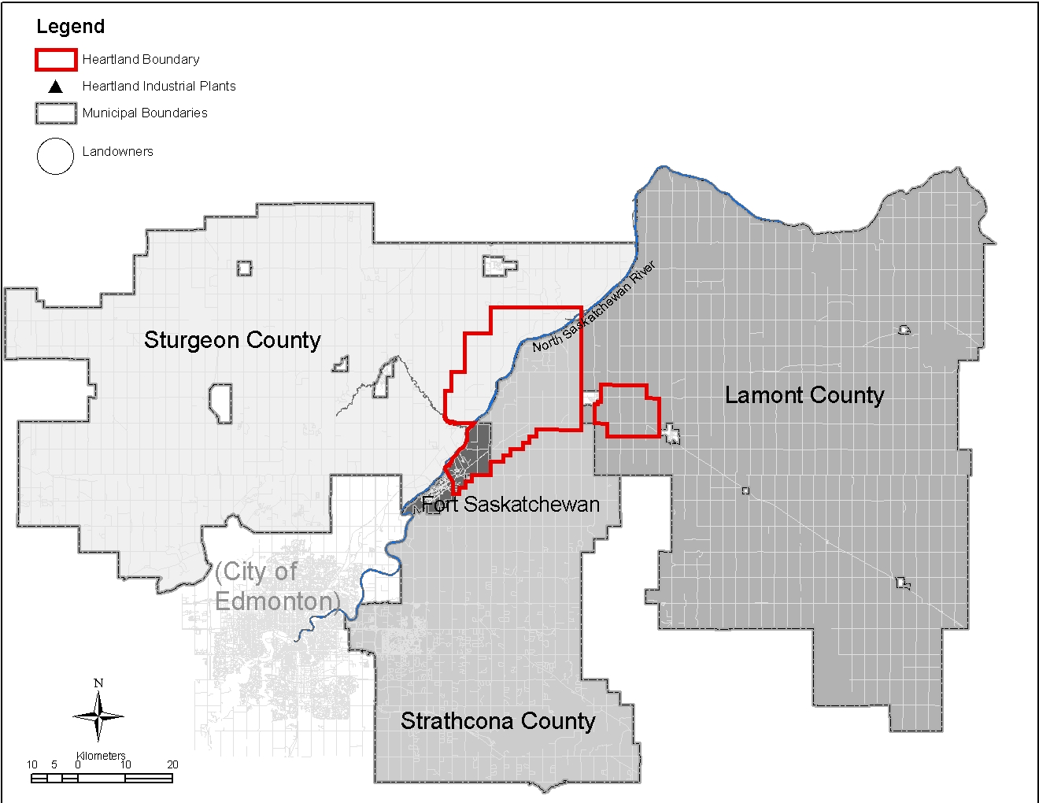

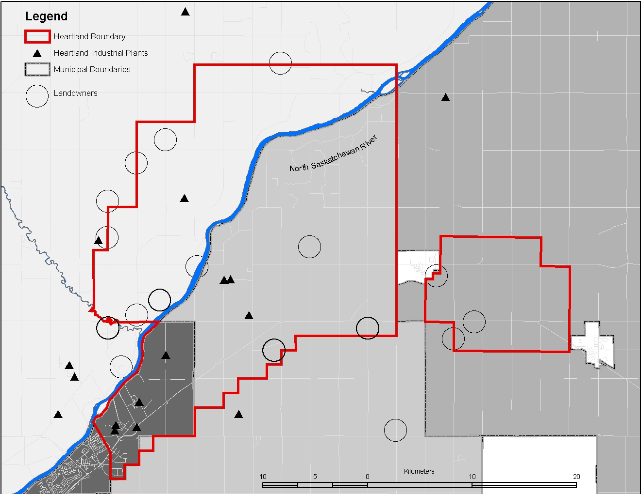

Fig. 1. The Alberta’s Industrial Heartland. The boundaries, intersecting the four municipalities, centers on an existing industrial region that follows the North Saskatchewan River. The geographic area in and around the AIH boundary includes farmland, acreages, rural subdivisions, and small towns.

3. Research Results

The results presented below are compiled from data collected between May 2003 and January, 2004. The project included a newspaper analysis, individual interviews, and a final group interview. A detailed review of the project’s methods can be found in Appendix B.

Newspaper Analysis

The newspaper analysis is comprised of articles from three local weekly newspapers that each provide coverage to parts of the resident population in the AIH. These include the Fort Saskatchewan Record, the Sturgeon Creek Post, and Strathcona County This Week. Content analysis of 1103 items (articles, press releases, public announcements, editorials, and letters) identifies three key findings about industry-related coverage, and two key findings about AIH-specific coverage.

a. Industry-related coverage

- Newspapers closer to the AIH had more industry-related coverage. Industry-related coverage averages three-fold higher in the Fort Saskatchewan Record than the other two newspapers (Table 1). The community advisory committee reports that this newspaper is favoured by local government and industry since it is perceived to serve the community most directly affected by the presence of industry.

Table 1. Newspaper articles. All articles relating to industry were collected by a manual search of back issues between January 1997 and December 2001.

Source | N
Sturgeon Creek Post | 269
Fort Saskatchewan Record | 656
Strathcona County This Week | 178
TOTAL | 1103

- Industry had a large influence on local news. Coding the content of all articles according to 14 pre-determined themes (Wakefield and Elliott, 2003) showed that public interest stories dominated news about industry. “Technology/ Industry/ Development” was the most common theme (21%) in all three newspapers. “Process/Public Consultation” and “Economy/ Business/ Employment” accounted for 16% and 13% respectively (Table 2).

Table 2. Key themes in newspaper articles. 14 themes were adapted from a coding scheme developed by Wakefield and Elliott (2003). All articles were read in their entirety, and then categorized into one of the key themes.

Key Theme | Source (N) |  |  | Total
Key Theme | FSR¹ | SCP² | SCTW³ | Total
Technology/Development/Industry | 139 | 54 | 35 | 228
Process/Public Consultation | 104 | 24 | 52 | 180
Economy/Business/Employment | 95 | 35 | 13 | 143
Environment/Pollution/Emissions | 62 | 37 | 4 | 103
Community Contribution | 65 | 15 | 9 | 89
Risk/Safety/Health | 47 | 17 | 14 | 78
Heartland | 23 | 20 | 28 | 71
Accident/Leak/Fire | 29 | 31 | 8 | 68
Community | 58 | 1 | 0 | 59
Conflict/Concern/Criticism | 15 | 15 | 10 | 40
Rezoning | 10 | 10 | 2 | 22
Nuisance/Noise/Traffic | 2 | 6 | 1 | 9
Heartland Citizen’s Coalition | 1 | 4 | 1 | 6
Agriculture | 3 | 0 | 0 | 3
Total | 653 | 269 | 177 | 1099⁴

¹Fort Saskatchewan Record
²Sturgeon Creek Post
³Strathcona County This Week
⁴Four items were categorized as “Other”

- Overall, local newspapers provided a balanced picture of the risks and benefits of industry in the region. However, each newspaper emphasized the risks versus benefits in different ways (Figure 2).

Risk themes
Benefit themes

Strathcona County This Week

Sturgeon Creek Post

Fort Saskatchewan Record

Fig. 2. Percent of articles coded by risk related themes versus benefit related themes of the three local newspapers. Note that only nine of the 14 themes are included in this table. The remaining four themes were not related to risks or benefits (therefore percentages do not add up to 100%).

b. AIH-specific coverage

- Conflict-oriented issues attracted greater newspaper attention. Relatively little coverage was given to the AIH during its inception and initial open houses (January 1998 – December 2000). However, newspaper coverage increased substantially after the Heartland Citizen’s Coalition was established in January 2001 and public hearings began (Figure 3). According to the community advisory committee, the coalition used newspapers as their voice to share concerns with the broader community. On the other hand, official AIH messages used other mechanisms (e.g. direct mail-outs) as their primary communication vehicle.
- AIH Partnership Formalized

- First open houses

Second open houses

Public hearings

- Heartland Citizen’s Coalition formed

- Third open house

- Additional public hearings

- Citizen’s Coalition loses in court

Heartland approved by all gov’ts

Strathcona County This Week

Sturgeon Creek Post

Fort Saskatchewan Record
Fig. 3. Newspaper coverage of the Alberta’s Industrial Heartland, 1997 - 2001. The 98 articles include those coded for primary, secondary, or tertiary theme as “AIH” . There was little coverage prior to late 2000 (the first public hearing), but between November 2000 and September 2001, there were only three months where all newspapers did not report the AIH.
- The balance of positive versus negative coverage of the AIH may have influenced community perceptions. The Sturgeon Creek Post and Fort Saskatchewan Record contained predominantly negative stories about the AIH, whereas Strathcona County This Week was more evenly balanced (Table 4).

Table 4. Newspaper coverage of the AIH. A total of 67 articles from the database were keyed according to the primary theme “AIH”. These were grouped as positive, negative, or neutral according to their headlines.

 | Positive | Negative | Neutral | Total
Fort Saskatchewan Record | 2 | 12 | 7 | 21
Sturgeon Creek Post | 0 | 18 | 2 | 20
Strathcona County This Week | 8 | 10 | 8 | 24
Total | 10 | 40 | 17 | 67

Individual Interviews

In two rounds of interviews (see Methods in Appendix A), participants communicated experiences and interactions relative to the social, cultural, economic, and political environment of the AIH. A total of 44 interviews (30 initial, 14 follow-up) revealed similarities and differences of people’s perspectives about the AIH, based on their personal and professional affiliations and past interactions. Key points included:

  - The consultations failed to meet the expectations of many community members and officials;

  - Community members and officials did not agree on whether the region set aside for the AIH should be agricultural, a place for country living, or an eco-industrial park;

  - Community members living in or near the AIH believed that they must bear the majority of the costs associated with industry, while they will share little of the benefits;

  - A considerable degree of mistrust existed among government, industry, and the community as a result of negative attitudes and experiences during the AIH consultations;

  - The conflict between the community and government was expected to continue, possibly hindering the implementation of the AIH;

  - It is uncertain who held decision-making power to drive the political and economic agenda for the AIH (i.e. government, industry, or the community).

To summarize, all participants agreed that the AIH is a community that is undergoing considerable change. Participants talked about both physical and social changes that are taking place in the region, both as a direct result of local policies as well as indirectly from broader economic, cultural, and political forces. However their perspectives on these changes depended on how they perceived the AIH would affect their own lives. The following sections provide more detail about the views and interactions of different groups according to these themes.

a. Public Consultation

Interview data revealed four key issues related to the public consultation process:

- Participants thought that the public consultations occurred too late in the AIH development process to be effective. Community members who participated in public consultations saw the AIH as a fait accompli, and believed that the concerns voiced to officials at public meetings were not really heard.

And that was another disappointing thing…you know they heard us, and I think they made up their minds already (001 – farmer)

The late timing of the public consultations limited the flexibility that planners had to accommodate legitimate issues raised by the community.

Maybe we should have listened to the people and shrunk the area. And someday if industry comes along and they want to locate outside of the area then you resolve it. (023 – elected official)

- Engaging the public was difficult. Officials who supported the AIH expressed frustration that despite intensive efforts to provide the public with information and opportunities for dialogue, most residents seemed to be uninterested.

The people that lived within the Heartland…and in the fringe were totally uninterested. Completely. We had to call special meetings to get them together to explain what we were doing so that they would understand. (023 – elected official)

In contrast, community members felt that the process should be sensitive to their busy lives, and that planners should not exclude people who cannot necessarily commit to expected types or levels of involvement. One official recognized how important it is to provide effective mechanisms to consult with the community.

That was one of the things that I strive for in terms of whenever we say we’re going to put together a community group and ask for input and consultation, or set up a task force to go do something, you sure as the hell better follow through with what you say you’re going to do. Because people are busy enough, you don’t need to waste their time. (020 – elected official)

- Participation fatigue was a problem for the community. Both community members and officials acknowledged that participation fatigue was an important factor that limited effective public involvement.

We’ve been through a lot of [sighs] procedures. I think people are very tired. We came hopeful many times. We’ve been disappointed so many times…You can’t give up. You’ve got to keep going. But it’s hard to be optimistic with the sense that [nothing] is going to change. But what we’ve seen so far, and many people are tired. (029 – country resident)

The Community Advisory Committee confirmed this perspective, pointing out that there are too many committees and meetings offered by municipalities and industry. Each is asking for public involvement, and there is no coordination.

- Community members and officials had different expectations.. While the community expected public consultations to respond to their concerns, officials viewed the public’s involvement as a method of information dissemination.

I think it was an information gap that was missing…We’re happy that’s the process we used. And we give them the information. They had an opportunity to review it, and come back to us, and tell us what you think it was. And that’s the route we took. (025 – elected official)

I’m not saying the decisions they made were bad decisions; it was more the process where we asked questions and we couldn’t get answers…They really didn’t do anything, and they’ve never admitted they didn’t do anything, either, and they haven’t done anything since then to say, “Yeah, we are looking into this.” (001 – farmer)

This difference in expectations caused community members to speculate that the only reason for public consultation is to meet legal and regulatory requirements.

What do I think? I think that they did it because they knew they had to…I mean, that’s pretty blunt, but I think it was just a political gesture on their part to do what the residents wanted them to do. (017 – absentee landowner)

b. Space versus Place in a Changing Landscape

Results from the interviews show three major issues that centre on the physical and social landscape of the AIH.

- Participants disagreed on how they viewed optimal land use in the AIH. Officials who were proponents of the AIH tended to emphasize the economic potential of the region, while landowners saw the area in the context of a social and cultural landscape. More recent immigrants from the city saw the area as an aesthetic alternative from urban life.

We have the infrastructure set up in this west end of the county. And the infrastructure I’m referring to is the water, the gas, the railways, and power. We have all that in place for it. And to me that’s probably the most important things for a new industry to set up. (025 – elected official)

Well, part of it was I love farming, and if you love what you’re doing, it makes it much easier than if you have to do it. I have been very happy on the farm. We’ve had a few ups and downs, but overall, it was good for us. (009 – farmer)

We bought the property with the idea that we would be involved with nature, away from noise and pollution. We’re very much environmentalists ourselves, and very involved in bird watching and camping and canoeing. We really like the outdoors, so we hoped this would be a special place for us to retire in, but it hasn’t turned out that way. (017 – acreage owner)

- The community is concerned by the uncertainty associated with potential industrial development. People with history in the region indicated that they have personal, family, and financial investments attached to their homes. They are concerned about how policy changes may affect the value of their land or its marketability. This uncertainty leads to a feeling of displacement from their homes – they want to stay, but feel they cannot, they want to leave, but cannot find a buyer for their property.

But this house was built from love; friends who helped, didn’t charge a dime. My elderly father on the roof, doing all kinds of wiring and plumbing and buying things for it. It was a big project; it meant a lot to all of us, and to have to leave it is something else…[but now] the “for sale” sign is up. If it wasn’t for them promoting and encouraging more industry in this area, I wouldn’t be moving. I could then live with [the industry] we got. But if they put another ten plants in there, I don’t believe it would be a safe place to live, whatsoever. (011 – acreage owner)

People don’t want to move in here. There has been a few newcomers coming into the area, but overall, we’ve found that people aren’t really that keen on coming into the area. (004 – farmer)

In no cases were any participants against the idea of continuing industrial presence in the region. In fact, the close social, cultural, and economic relationship between industry and the local community was recognized by all participants. Community members acknowledged the value of industry, but were concerned that its expansion is not proceeding responsibly.

It’s a good thing. So I’m all for this development. But I must remind the people who are creating it, who are guiding this development, the Heartland people, not to forget the people who live here. (016 – Country resident)

- Rural restructuring has weakened the rural community. We noted above that industry has been important in sustaining the local rural community. The long relationship between farmers and local industries was generally viewed as a positive one. However, the decline of family farming and the increasing presence of both industry and rural “lifestyle” dwellings and communities has complicated the social and cultural landscape.

So if you want to maintain a standard of life for your family and your young life, well, there it is: it’s industry or nothing. And I think a lot of these people are starting to see that, that this is about the last thing we’ve got that’s going to create employment. You look at our housing development around here, well, indirectly, it’s all tied to industry. If the jobs weren’t here, the people would be leaving, they don’t need the houses. It’s a vicious circle. Where 40, 50 years ago, the agriculture sector employed quite a number of people, but they don’t do that any more. (012 – farmer)

The smaller farms…are just kind of subsisting, and their children aren’t interested in taking over because they don’t see much future in small farms…Probably the biggest difference I find is because there are less farmers now, we have less voice and we have less votes. But there is a lot of acreages…so we’re outvoted 8 to 1 on the land that we farm…but we’re trying to make a point that agriculture is important, and here’s one more area where agriculture is not being addressed…it’s just being thrown away. (001 – farmer)

That was one thing I envy about people way back when: you were either a town dweller or a farmer. There was no subdivisions, and if you were a farmer, you were all farmers. There was no dissention among the troops, and there was no categorizing or anything…We’ve created all these little categories, where somebody’s got to fit into a lot of little categories. (004 – farmer)

c. Risks versus Benefits

Further industrial development in the AIH will create new opportunities as well as pose new risks to the people who live in the region, however community members indicated that they have concerns about how the risks and benefits of further development will be distributed.

- There are few perceived local benefits. Overall, participants see the AIH as a policy designed to bring a unifying image to the region, which is attractive to outside investors.

We’re a leader in the province and the country and the world, and we need a million bucks to fix or build a couple of new roads, we’ll get that very favourably, because we’re not piecemealing it, and they’re not dealing with four different municipalities in one area, they’re dealing with one entity that’s created by four, so it makes it a little bit easier to negotiate and speak to them on that. (020 – elected official)

They want attract more businesses, so for them it’s kind of the far corner of the county. It works together with the other counties so they can split some costs of developing. (002 – farmer)

When asked about their personal benefits from being a part of the AIH, most community members were less enthusiastic.

What benefits?…Well, the benefits that are going to show up as the Heartland develops, they will be good for the county, the province, the country itself, the common good. I think it will be great to have this industry come in here and give employment to God knows how many people, create opportunities for people. But to us, well, we have to move away. (016 – acreage owner)

One elected official who was sympathetic to the concerns of the community was particularly critical about the issue of who benefits.

“for the greater good,” you can always justify that; that’s not hard to do. If I said to you tomorrow you won’t have a job if that plant doesn’t go in…and someone uses that as a reason for allowing industry, well, then I guess you’ve created enough fear that people will back off and say, “Well, let it be, because I can’t afford to lose my job or my quality of life.” Quality of life you lose anyway with the type of activity that we have. Quality of life is an issue that you can’t give back to these people in the end, because when they have the flaring and they have all that stuff happening, and they’re told to drive downwind because there’s some smell this morning, then it’s no longer a question, “Have I lost control of my life?” You bet I have. (024 – elected official)

- Sociopolitical affiliations influenced risk perceptions. Community members expressed fear over the uncertainty of risks, and the inability of modern science to address these uncertainties. Their concerns were amplified by experiences with existing industries, and perceived risks to their health, safety, and quality of life.

No one is able to explain what happens when emissions from a plant drift over another plant and the two mix. Is there an inversion factor? I’m talking in terms that I’ve been made aware of through working for industry. It’s scary. (003 – resident of rural subdivision)

By comparison, supporters of the AIH tended to downplay landowners’ risk concerns as paranoia, or as NIMBY (Not In My Back Yard) syndrome.

So when I asked them where they had worked or where they do work, the majority of them work in the plants. They want to pick up the paycheque, but they don’t want to look at it from their back window (030 – non-elected official)

- There is uncertainty about who is responsible for assuring public safety. While participants agree that responsibility for managing risks should fall upon competent professionals, there is no clear consensus as to who should be accountable, leaving community members wary of current risk management practices.

My question is having industry monitor its own emissions is like having us write our own speeding tickets. (011 –acreage owner)

We have enough industry. And they’re saying the industry we have is safe but they really wouldn’t want us to build there because it wouldn’t be safe for us, as far as health goes. So on one hand, they’re telling you it is safe, but on the other hand they’re saying, “We don’t want you to build there, because it wouldn’t be safe.” (013 – Absentee landowner)

In the face of this uncertainty, officials resorted to claiming that responsibility is shared by “everybody”. However, this attitude was also interpreted as a cop-out, allowing governments and industry to offload the burden of accountability.

I don’t see how you can come up with the single-point responsibility…it’s sort of a triad here, from the community, the industry, and the municipal perspective, you’ll wind up with each of you pointing at the other one, and everybody abdicating the role of being able to explain risk. (027 – industrial representative)

Community members felt that responsibility was being unfairly shifted to individuals and that they should not have to personally bear the burden of risks imposed by others. One participant commented critically about having to opt-in to a voluntary community notification system.

Because things like that, you just don’t get around to doing. It’s not like we have a mailbox outside the door that we can stick our mail in. It’s one more thing on the list of things to do that don’t always get done. (011 – acreage owner)

d. Trust, Attitudes and Relationships

Relationships among government, industry, and the community stem from past and present interactions, both related and unrelated to the AIH. The status of relationships has important implications for the success of public consultations. The following three key issues identify how relationships may have been compromised among AIH stakeholders.

- Many landowners did not trust their local government. Participants acknowledged that there were problems with the public consultations. Several suggested that this represented a broader sense of mistrust toward government in general.

Well, I think part of the reason people don’t go to these meetings and everything else is [because] there’s not much respect that what they say will actually be done. For the decision makers, for the politicians, it’s all the provincial government or the city government, it’s generally felt that we really don’t trust them that they’ll do these things. (005 – farmer)

Vested interests and lack of accountability to the community was seen as a particularly critical problem.

Administration seems to have a lot of power. They seem to be able to lead council. (029 – country resident)

Even among elected officials, administrators were viewed as occupying a powerful position in decision-making.

So what happens when you find your relationship with the administration to be somewhat strained…because you need administration to work with you. But again, you have to come forward to administration with some credibility and with some consistency. (024 – elected official)

- Mistrust occurs in two directions. Not only was there a problem with a lack of trust by the community towards government, but the reverse was also true. A tendency among supporters of the AIH to discount the community rested on perceptions that citizens are compelled by self-interest, low-education, sentiments of a “vocal minority”, or general irrationality. This created an environment of mistrust toward the public.

They didn’t want to be in the buffer zone because there was no money there, they didn’t want to be in the environmental zone because there was no money there. (030 – non-elected official)

In terms of people that don’t have that education or don’t have that knowledge base… you would probably have more of a diverse opinion.. In terms of, “ we have the people to work here, we already have more industry, we don’t want any more, or we want more”…you’d probably get a more helter-skelter approach to that. (020 – elected official)

And we had some open discussion with these people. And the interesting scenario was that this small group of people were totally opposed to anything and everything. (025 – elected official)

So there’s always going to be a percentage of our citizens in Fort Saskatchewan that are going to say, “Well, gee, I wish we didn’t have industry here,” you know. They would like to see a small community with no industry but they still want all the services and want everything. Well, it doesn’t happen. That’s human nature. They want everything for nothing. And so there’s got to be some trade-off. (026 – elected official)

This lack of trust by officials toward the community contributed to the breakdown of relationships among organizers and participants of public involvement processes. Feedback from the community advisory committee acknowledged this as a problem that needs to be addressed.

- Trust was easily compromised, and will be difficult to regain. Certain key incidents during the public involvement process contributed to the lack of trust between government and the community. For example, at one meeting, a non-elected official angered meeting participants by refusing to answer their questions, despite earlier promises that there would be dialogue.

I think they’ve lost [our] trust, the county has, because of this. And that’ll take time to heal. It’s something that has happened, and just like anything, it’ll take time and maybe different people to change that attitude. (017 – acreage owner)

e. Forecasting and Future Expectations

Participants’ expectations about the success of future development in the AIH hinged on several unresolved issues from past failures in public consultation and on a changing world economic situation.

- Public opposition is expected to continue. Most community members expected that future protests are inevitable and will inhibit efforts to promote further industrial development in the AIH.

They’re going to have quite a few battles on their hands…a lot of those people have put a lot of their effort and money and resources into building their places. So they don’t want to have to face industry close to them. So it’s going to be a hard line for industry to come in and be welcomed with open arms…I think there’s going to be major battles down the road. Even if industry comes in now and buys property, that doesn’t necessarily mean that they’re going to be allowed to build what they want to build. Because there’s enough people around here now that will stall it. (004 –farmer)

This sentiment was also felt by local government officials.

My opinion is that if conditions don’t change, it’s going to be very difficult to locate industry within the Heartland. It is my feeling that industry will not locate where they’re not wanted. Because the fight is going to be hard and great to make it abandoned. (023 – elected official)

These predictions do not bode well for any of the groups who are interested in working constructively to improve relationships and build a more positive environment.

- Changing world geopolitical conditions may influence the AIH. When asked to speculate about the future of the AIH, participants disagreed on whether the global economy would favour or hinder the energy industry in Alberta. Some officials pointed to changing political (e.g. Iraqi regime change) and economic (e.g. labour costs) circumstances as having a negative influence.

Because the Alberta Advantage isn’t as strong any more. Feedstocks are expensive. There were opportunities in Iran and Iraq and Kuwait, and that’s where companies are looking right now. (022 – elected official)

If you think about it, Agrium has gone to Argentina and have opened up the same type of plant there. They’re saying that they can do it for 30, 35 percent less than they could do it here in Canada. (024 – elected official)

Others pointed to the cyclical nature of the oil and gas sector with some degree of optimism.

Has things changed in the last few years? Of course they have; it’s a global market, and through economic policies set down by the province and economic policies set down by the federal government…but when people say that Alberta’s not the boom that it used to be, it’s cyclical, right? (020 – elected official)

f. Power and Politics

Power relationships and politics played an important role in participant’s perceptions of the process and outcomes of public consultations and the relationships among stakeholders in the AIH.

- The community felt powerless against the local government. The perception that government has an overwhelming political incentive to push the AIH through made some participants wary of the entire process, and reluctant to have their opinions represented.

And I don’t have the money to fight them. And I don’t think there’s enough people. I mean, they tried to stop it, but it didn’t do any good. It’s one of those things: unless you have power and money, you’re not going to get your way. (013 – absentee landowner)

Local government deferred to provincial interests. The AIH exists within a pro-industrial provincial economy that is primarily focused on the development of its rich oil and gas reserves.

Because in our lower level of government, which is the municipalities, you're a creation of the province, so you’re actually like a child. They’ll let you throw a temper tantrum, but then they’ll come back and say, “No, no, no, no. You will follow this.” That’s where we have the Municipal Government Act, which is our Bible and tells us what we’re supposed to do and what we’re not supposed to do. (024 – elected official)

Similarly, the close relationship between the provincial government and the industry lobby led to the belief that industry is driving the political agenda.

There’s industry on that and I think they’re the tail wagging the dog. (018-country resident)

- Power can exist in the general public, so long as members have the will to exercise it. Despite the upward deferral of power, grassroots public power was believed to be an influential, but untapped resource, and one that should not be discounted by decision-makers.

I think that the politicians have to realize that the municipality does not belong to them, that we don’t have the power. [The county] belongs to the people, and they have the power. (023 – elected official)

Group Interview

The group interview included seven participants representing industry, local government, and the community. The purpose of this interview was to allow participants to confirm or to critique some of the findings from the project.

The interview clarified the polarized positions taken by those involved in the AIH debate. The participants’ stated positions were consistent with many of the issues identified above, however, more importantly, they acknowledged that their views were not so entrenched that they were unwilling to re-examine them, given the right opportunity. The following three key issues summarize the outcome of this interview.

- The community believes that there has been little resolution of the issues that contributed to conflict.

- There was no clear consensus on viable courses of action to improve the conditions for the community, nor how to improve relationships between the community and government.

- Participants acknowledged that trust is a primary concern, and that both sides must take responsibility for rebuilding trust showing goodwill toward past mistakes. Concrete solutions will not be negotiable until trusting relationships are achieved.

4. Conclusion

The AIH provides an informative case study of the implications of industrial investment in rural areas. This research has shown how rural economic development can result in local debates over appropriate land uses.

In the AIH, the rural population comprises both farming and country residential communities who have interests that differ from those of local governments who want to create new economic opportunities. At stake in the development of the AIH were concerns voiced by the rural community that the benefits of industrial investment to the wider population may not be worth risks to health, safety, and quality of life that may be imposed on them.

Results show that community involvement was a key issue in decision-making. A successful outcome for the AIH depended on reconciling competing views about what the future should look like on the rural landscape. However, a contentious public consultation process that resulted in unmet expectations and mistrust created conditions for community dissatisfaction toward the AIH and may inhibit positive relationships in future deliberations.

Overcoming these problems will require improved management of community consultation that is more sensitive to the circumstances of the local communities in the AIH. A series of recommendations based on the project results will form a framework for community consultation to be provided in the final project report. This framework may also benefit consultation principles and practices for rural communities in other jurisdictions.
References

Wakefield, S., & Elliott, S. J. (2003). Environmental risk perception and well-being: Effects of the landfill siting process in two southern Ontario communities. Social Science and Medicine, 50, 1139-1154.

Appendix A: Community Advisory Committee

Murray Kerik | Director, Zone 7 | Alberta Cattle Commission
Ward Toma | General Manager | Alberta Canola Producers Commission
Yvonne Sinkewich | Contact Person | Peace River Organic Producers Association
Duane Yaworksi | Contact Person | Alberta Surface Rights Federation
Anne Brown | Contact Person | Heartland Citizens' Coalition
Larry Wall | Executive Director | Alberta's Industrial Heartland Association
Barb Korol | Director of Public Relations | Dow Chemical
Brad Trefan | Senior Director, Industry Development Branch | Alberta Economic Development, Government of Alberta

Appendix B: Methods

Newspaper Analysis

The newspaper analysis included three of the local newspaper publications (see Table 1). We focused on three newspapers that were the main source of information about the AIH to residents of the region. Other sources of media did not play a significant role in coverage about industry (i.e. television, radio) to the local community.

Articles were retrieved by manual search through back issues in local museums and libraries. Selected articles included: articles written by journalists, letters, editorials, advertisements, public announcements, and cartoons. These were catalogued according to date, newspaper name, page number, length, and headline. Each article was coded according to a set of 14 pre-defined themes using standard content analysis techniques (Wakefield and Elliott, 2000).

Interviewing

Interviews included a total of 33 participants in 44 interviews selected by both snowball and random methods. The sample comprises five groups, including 18 landowners (N= 9 random, 9 snowball), of which 11 were farmers or absentee landowners, seven owned country residential properties; nine were local politicians or administrators, and three represented industry, industrial associations, and the media.

To achieve randomness of the landowner sub-group, the AIH boundary was overlaid onto municipality land ownership maps, selecting a total of 259 eligible landowners. An online directory yielded a total of 126 unique telephone numbers (48.6%) which were called at random to recruit the desired sample (N = 40: 27 unreachable, 4 declined, 9 participated; Response rate = 71.4%). Geographic distribution of the random and snowball landowner sample can be seen in Figure 1.

All participants in the landowner sample, as well as half of the non-landowner sample, preferred to be interviewed in their homes. The remainder of the interviews were conducted at the participants’ workplaces. First round interviews varied from 29 to 83 minutes, with an average of 45 minutes. Follow-up interviews ranged from 40 to 120 minutes, with an average of 74 minutes.

Table 8 identifies the participants’ demographic information. Participants were predominantly middle aged, long-time residents, married, and male. Most had either a high school or technical diploma and had a relatively high income. There were no visible minorities in the sample.

Table 8. Participant Demographics.
 |  | Total
Location | Lamont | 5
(n=30) | Sturgeon County | 11
 | Strathcona County | 6
 | Fort Saskatchewan | 8
Age | 20-40 | 2
(n=24) | 40-60 | 13
 | >60 | 9
Residency | < 10 years | 2
(n=20) | 10 – 20 years | 3
 | > 20 years | 15
Education | High School or less | 4
(n=21) | Technical/Professional | 9
 | University | 8
Marital Status | Single | 0
(n=23) | Common-law | 1
 | Legally married | 21
 | Separated/Divorced | 0
 | Widowed | 1
Gender | Male | 22
(n=30) | Female | 8
Background | Agriculture | 9
(n=30) | Acreage/rural subdivision | 7
 | Absentee landowner | 2
 | Government and Elected Government Officials (past and present) | 9
 | Industry/industrial associations/media | 3
Family Income | <$40,000 | 3
(n=22) | $40000-50000 | 4
 | $50000-60000 | 3
 | $60000+ | 12
The first interviews (n=30), focused on the following areas:
- Personal and professional background and life experiences in the region;
- Views on the relationship between industry and the community;
- Role in public involvement processes;
- Perspectives on the differing opinions expressed during the AIH development.

A total of 20 people from the original sample were selected to participate in a second interview. They were selected based on the quality and depth of their interviews (i.e. potential to provide further in-depth information). After four attempts to call the participants, a total of 14 agreed to participate. During the interviews, participants were asked to respond to a written summary of the preliminary findings focused on four specific themes that emerged from the first round:

- Physical and social changes taking place on the local landscape;
- The benefits that are accruing to the local community as a result of the AIH;
- The risks that are threatening the local community and environment as a result of the AIH;
- Evaluation of the role and value of public involvement in decision-making about the AIH.

Using a constant comparative method, these interviews were subjected to a rigourous analysis procedure, yielding overarching themes from which we derived our main findings. The second round of interviews provided a means to focus the investigation on key elements of the main findings.

A total of seven participants took part in a final group interview. These participants were recruited first from the 20 participants who were selected for follow-up interviews (n=6), then from the remaining 13 participants in the total sample (n=1). The group interview lasted for two hours. To begin, participants were asked to provide a brief summary of their personal backgrounds, experiences or involvement with the AIH, and perspectives on the changing community and landscape. Following introductions, the meeting focused on confirming the findings from the individual interviews and discussing recommendations for more effective public consultation.

Appendix C: Heartland Timeline 1998 – 2001

Date | Event
1993 | Strathcona, Ft Saskatchewan, Sturgeon, Lamont, Ft Saskatchewan Regional Industrial Association become informal partners
27 May 1998 | Partnership formalized to become the Alberta’s Industrial Heartland Association
Sept – Oct 1999 | AIHA review of background material, study area
03 Nov 1999 | Josephburg open house
04 Nov 1999 | Redwater open house
09 Dec 1999 | Workshop for 60 key stakeholders to provide detailed information
Jan 2000 | 3 Area Structure Plans prepared and reviewed
Feb 2000 | Revised plans presented to AIHA partners
16 Feb 2000 | Revised plans presented in Gibbons open house
17 Feb 2000 | Revised plans presented in Ft Saskatchewan open house
10 May 2000 | Final open house in Gibbons for complementary plans
11 May 2000 | Final open house in Bruderheim
09 June 2000 | Invited industry reps meet to discuss plans
25 June 2000 | Fort Saskatchewan public hearing on Bylaw #C19-00 and C8-01
30 June 2000 | Steering committee meeting attended by municipality representatives to provide input on public concerns
10 Aug 2000 | Finalized Complementary Area Structure Plans (CASP) submitted to steering committee
Aug 2000 – June 2001 | Extensive review and public/industry/regulator consultation
Nov 2000 | 24 landowners to be bought out by Strathcona County
Nov and Dec 2000 | Four public hearings on the revised CASPs.  Fort Saskatchewan (Dec. 11)
Nov 2000 | “Newsletter #4” encourages participation at public hearings
18 Dec 2000 | Steering committee meets to discuss results of public hearings and alternative approaches to the planning process
04 Jan 2001 | Heartland Citizen’s Coalition formed
 | Letter sent to Sturgeon County Council
08 Jan 2001 | Steering committee meets to detail plans
10 Jan 2001 | AIHA and municipality staff meet with town of Bruderheim at their request to discuss Heartland and CASP project
Jan – June 2001 | Facilitator assisted AIHA and municipalities for extended and intensive public consultation: with regard to each CASP
March 2001 | Open house
23 April 2001 | 2nd and 3rd readings of Fort Saskatchewan Bylaw #C19-00
April 2001 | Additional public hearings
25 June 2001 | Ft Saskatchewan public hearing
10 April 2001 | Final approval by Lamont and Sturgeon
26 June 2001 | Final approval by Strathcona
13 Aug 2001 | Final approval by Ft Saskatchewan
Oct 2001 | Court of Queen’s Bench ruling against Heartland Citizen Coalition (applicant) versus Sturgeon County (respondent)

